**Fluid and Nutrition**

**Learning outcomes**

1. Understand the principles of hydration, nutrition   
and food safety

2. Support individuals to have access to fluids in accordance with their plan of care

3. Support individuals to have access to food and nutrition in accordance with their plan of care.

**Food safety**

* Food safety is essential when preparing and handling food
* Not all substances and objects that can cause harm or illness can be seen
* People can become ill from eating food that tastes normal and looks safe

It is important that whenever food is provided to individuals that it is handled, stored, prepared and delivered in a way that meets safety requirements. If the role of health and care workers includes preparing or handling food, they must have the knowledge and skills to do so safely.

**Food hazards**

Food must be prepared and stored in ways that prevent contamination. Contaminants could be:

**Physical**

Objects that could be in food when it is bought or introduced when preparing food e.g. bones or bits of packaging. Look for objects which should not be in the food.

**Chemical**

Chemicals that could be harmful if eaten such as pesticides, weed killers or cleaning chemicals. Wash fruit and vegetables before preparation and avoid spraying cleaning products near food.

**Allergenic**

Substances which cause extreme reactions in individuals allergic to them. Examples include nuts, eggs, shellfish, gluten and milk. Foods containing allergens should be prepared and stored separately to those which don’t.

**Bacterial**

Pathogenic bacteria can be transferred to food during storage, handling and preparation. They can multiply to harmful levels if the conditions are right. Effective food safety principles should be followed to remove these risks.

All organisations that provide food, including care and healthcare providers covering pre-packed and non-prepacked foods are legally required to provide a warning if foods contain 1 of the 14 allergenic substances that are covered by the legislation.

The 14 allergens are:

* Eggs
* Milk
* Fish
* Crustaceans (for example crab, lobster, crayfish, shrimp, prawn)
* Molluscs (for example mussels, oysters, squid)
* Peanuts
* Tree nuts (almonds, hazelnuts, walnuts, cashews, pecans, brazils, pistachios, macadamia nuts or Queensland nuts)
* Sesame seeds
* Cereals containing gluten (wheat (such as spelt, Khorasan wheat/Kamut), rye, barley, oats, or their hybridised strains)
* Soya
* Celery and celeriac
* Mustard
* Lupin
* Sulphur dioxide and sulphites (at concentration of more than ten parts per million)

**Vulnerable groups**

Some groups of people are more vulnerable to food-related illnesses because of a weakened immune system. These groups can include:

* Babies,
* toddlers,
* children and teenagers
* Pregnant and breastfeeding women
* Elderly people
* Those who are living on a low income
* People in prison
* People in hospital

**Preparing food safely**

1. **Remove jewellery before preparing food:** Jewellery can make hand washing less effective meaning that less bacteria are removed. It also means that small items cannot drop into food as it is being prepared and become physical contaminants.
2. **Wash your hands thoroughly before touching food:** Micro-organisms such as bacteria can live on the skin and be transferred to food during the preparation process. Effective hand washing before handling food helps to remove these micro-organisms.
3. **Wipe equipment in hot water between uses:** Wiping equipment is not an effective way of removing all contaminants. Equipment should be washed in hot soapy water between uses to remove traces of allergens and micro-organisms.
4. **Ensure food is cooked thoroughly:** Bacteria and micro-organisms are destroyed by heat. Thorough cooking will kill bacteria present in and on food making it safe to eat.
5. **Store food in sealed containers;** storing food in sealed containers stops it becoming accidentally contaminated by objects, chemicals or allergens.
6. **Food stored in a fridge should be labelled, dated and kept at or below 5ºC:** Storing foods at an appropriate temperature slows down bacterial multiplying, labelling foods properly and ensuring that it is used within the use by dates should ensure that food is safe to eat.
7. **Store raw meat above ready to eat food:** Raw food can drip juices onto whatever is stored underneath contaminating it with bacteria. If this food is intended to be eaten without cooking (e.g. salad or cooked foods) bacteria will not be destroyed before it is eaten. Raw meat should be stored below ready-to-eat foods.
8. **Prepare raw and cooked foods at the same time in the same area:** Raw and cooked foods should be prepared separately to ensure that raw foods do not contaminate ready to eat foods. If using the same area, it should be thoroughly cleaned and disinfected after preparing raw food.
9. **Wash equipment in hot, soapy water or in a dishwasher if available:** Washing equipment in hot soapy water removes bacteria. If temperatures are high enough bacteria will be killed. Higher temperatures are achievable in a dishwasher.

**The importance of nutrition for health and wellbeing**

To stay healthy we need a diet that includes the correct balance of the following:

**Carbohydrates-**Good sources include bread, potatoes, rice and pasta

**Protein**-Good sources of protein include milk products but also in meat, fish and beans

**Vitamins**-Fruit and vegetables are good sources of vitamins

**Fibre-**Fruit, vegetables, wholemeal bread, nuts and seeds are high in fibre

**Minerals-**Milk products are good providers of calcium and liver and shellfish are full of iron

**The eat well plate**

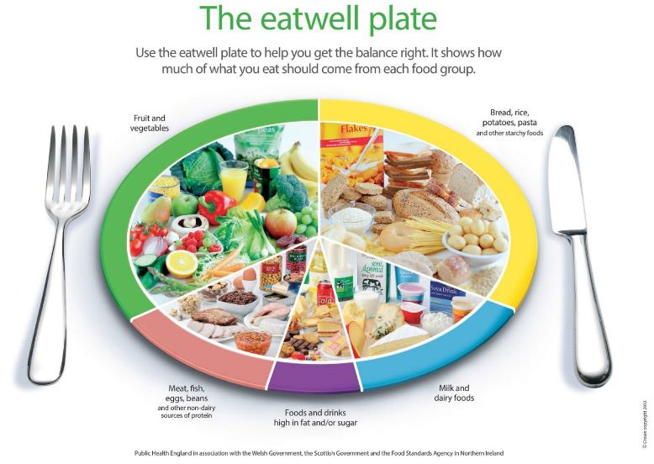

The eat well plate has been developed by Public Health England in association with the Welsh and Scottish Governments and the Food Standards Agency in Northern Ireland. It is the model used widely in the UK to illustrate a healthy diet and is suitable for most groups of people. It shows the five main food groups and the proportions of each food group recommended as part of a daily healthy diet.

**The food groups are:**

33% - Fruit and vegetables

33% - Bread, rice, potatoes, pasta and other starchy foods

12% - Meat, fish, eggs, beans and other non-dairy sources of protein

15% - Milk and dairy foods

8% - Foods and drinks high in fat and/or sugar.

**Identifying poor nutrition**

Malnutrition is a common phenomenon, and many are at risk of becoming so; the symptom could be:

- Muscle weakness - Feeling tired all the time

- Increased infections - More falls

- Constipation - Lack of energy

- Gaining or losing weight - Changes in behaviour

- Depression - Poor wound healing

**Malnourished:** An individual whose diet does not contain the right balance of nutrients can become malnourished. This could be under nutrition, when a person does not get enough nutrients or over nutrition, when a person has more nutrients than they need.

**Supporting people to eat**

Equipment is available to support independent eating and drinking, and to promote dignity and respect

**Examples include:**

* Technology such as clocks or reminder messages to tell someone when it is time to eat or drink
* Cutlery with shaped and padded handles that can help with gripping
* Two-handled mugs to help people with poor grip, tremors or weak wrists
* Cups with lids to reduce the risk of spillage
* One-way straws that help people to drink without the need to lift cups and glasses, even if muscle weakness has reduced their ability to suck
* Non-slip mats which stop plates from moving around while people are cutting food
* Plates and bowls with high sides to prevent food falling off the edges

Individuals should have plenty of time to eat, not be rushed and be able to choose whether they would like to use any equipment offered.

If health and social care workers have concerns that an individual is not eating or drinking enough despite being encouraged and supported, you should discuss your concerns with your manager.

Advice may be sought from a specialist such as a dietician or a nutritionist.

**Staying hydrated**

**Fluid and hydration**

The body needs fluids to carry out basic processes that enable it to function correctly. For example:

* Digesting food and enabling nutrients to be absorbed
* Enabling blood to circulate around the body
* Removing waste products via urine and faeces
* Keeping cells and tissues moist, helping to avoid infection
* Controlling body temperature by perspiration

**Maintaining brain function**

An individual's fluid requirement will be included in their care plan

* Most individuals should have about 1.5-2 litres of fluid each day
* Individual’s with some medical conditions will need to drink less

Sometimes an individual must not eat or drink anything for a set period   
of time;

* Some medical conditions, such as certain types of heart condition or kidney disease will require individuals to drink less
* There are times when an individual must not eat or drink anything for a set period of time, for example before an operation. This is known as nil-by-mouth and will be clearly shown in their care plan. This must be followed for their own safety

**Types of fluid**

* Most ordinary drinks (for example, fruit juices, milk, tea and coffee in moderation and low sugar drinks) count towards a person’s fluid intake
* Drinking a lot of alcohol can lead to dehydration
* Water is the best fluid to rehydrate the body.

**Identifying poor hydration**

**Early signs and symptoms of dehydration include:**

* Feelings of thirst as the body tries to increase fluid levels
* Dark coloured urine as it tries to reduce fluid loss
* Headaches, tiredness and confusion, as the flow of blood to the brain decreases. (These signs might also indicate an undiagnosed health problem, for example type 2 diabetes.)

**Ongoing dehydration can contribute to:**

* Constipation
* Urinary tract infections, which are prevalent in some groups in care
* Kidney stones and infections
* Poor wound healing

If dehydration remains untreated, it can have serious consequences. Blood circulation can be affected, or kidneys can fail.

**Early signs and symptoms of dehydration include:**

* Feelings of thirst as the body tries to increase fluid levels
* Dark coloured urine as it tries to reduce fluid loss
* Headaches, tiredness and confusion, as the flow of blood to the brain decreases. (These signs might also indicate an undiagnosed health problem, for example type 2 diabetes.)

**Ongoing dehydration can contribute to:**

* Constipation
* Urinary tract infections, which are prevalent in some groups in care
* Kidney stones and infections
* Poor wound healing

If dehydration remains untreated, it can have serious consequences. Blood circulation can be affected or kidneys can fail.

**Promoting adequate nutrition and hydration**

It is important to work in person centred ways to ensure that food and drinks provided meet individuals’ needs

**Consideration are;**

Do they have beliefs or preferences that affect the foods that they eat?

**Religious requirements:**

* Fasting
* Food restrictions
* Fluid restrictions on stimulants (caffeine and alcohol)

**REMEMBER:** Do not make assumptions; each individual is different and even the ways that an individual observes their religion can vary. The individual should be asked about their specific needs and preferences.

**Food preferences:** an individual's likes and dislikes for example some people have a ‘sweet tooth’ and like desserts whilst other might prefer to finish a meal with a cheese platter.

**Beliefs and ideology:** Vegetarians not eating meat, vegans not eating meat or dairy products

**Are there any foods they should not have because of health conditions or medication?**

* Some people on certain medications for depression should not have cheese
* People with raised blood cholesterol levels may be advised not to have too much saturated fat such as butter, fried items and pastry
* People with diabetes may be encouraged to avoid too much sugar found in sweets, chocolate, sugared breakfast cereals, cakes and puddings and encouraged to eat fewer of these or smaller portions.
* Those who have high blood pressure may be advised to limit salt
* Anyone who is obese should be encouraged to limit sugary and fatty foods

**Do they need support to eat and/or drink?**

* Forgetting to eat (perhaps due to dementia)
* Side effects of medication which may affect appetite or cause sickness
* Poorly fitting false teeth
* Physical illness such as a stroke which may have affected the individuals muscles around their mouth for chewing or hand for lifting drinks
* Depression which may cause poor appetite
* A visual impairment which may affect the way a person sees their food to eat it

**Supporting good hydration**

Individuals’ care plans will state how to support them to maintain their hydration.

* Individuals should have access to fluid at all times, unless it is restricted for medical reasons
* Individuals should be encouraged not to wait until they are thirsty   
  to drink
* Individuals should be offered drinks to remind them to drink
* Drinks need to be refreshed regularly
* Drinks should be within easy reach for those with restricted movement or mobility